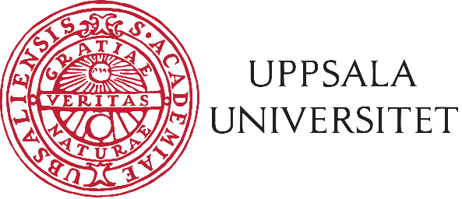
PhD Student Board
Medical Faculty
Agenda

The PhD student council of the Medical Faculty hereby invites you to the MDR meeting;
Friday 29th of November, 12.15-13.00, Boströmrummet (A11:2), BMC
Topics:
- Opening of meeting
- Election of corrector
- Co-options
- Adoption of agenda
- Confirmation of minutes of previous meeting
- Christmas party
- Messages:
  - Faculty board (Emelie)
  - Committee for education on research level (KUF) (Markus)
  - PhD student board at Uppsala Student Union (DN) (Loora and Aida)
  - PhD student board at Faculty of Pharmacy (FDR) (Kristel)
  - Committee for the Medical Faculty (Medicinska Kommittén) (Vacant)
  - Rekryteringsgruppen för medicinsk fakultet (Recruitment board) (Vacant)
  - Universitetsnämmnden/-styrelsen (Vacant)
  - Committee for Docenturkommittén (appointment of associated professors/senior lecturers) (Vacant)
  - Medicinska sektionsrådet (Vacant)
  - Library cooperation group (Vacant)
  - Committee for equal opportunities (Vacant)
  - SVEK (Kommittén för Samverkan) / Collaborations Committee (Vacant)
  - EXODIAB (Vacant)
  - Representantive in Infrastrukturkommittén/Infrastructure Committee (shared with FDR)/ (vacant)
  - Messages from Medical Faculty departments’ representatives
    - Department of Neuroscience (Harmen Koning)
    - Department of Immunology, Genetics and Pathology (IGP) (Vacant)
    - Department of Medical Cell Biology (MCB) (Kristel Parv)
    - Department of Public Health and Caring Sciences (vacant)
    - Department of Surgical Sciences (vacant)
    - Department of Women’s and Children’s health (vacant)
    - Department of Medical Biochemistry and Microbiology (IMBIM)
    - Department of Medical Sciences (vacant)
- Other matters
- Closing of the meeting

